*Arch Project VON Architecture*

1. Press Test simulation.

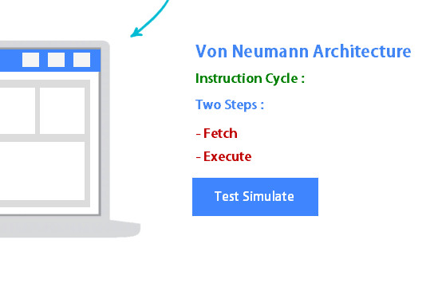

1. Add Code Operation and PC Address and instruction.

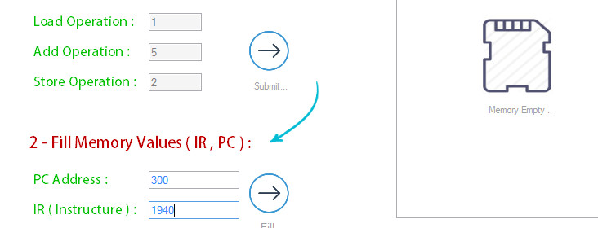

1. Press Start.

